# Splunk dashboard and reports

Creating reports for recurring searches:

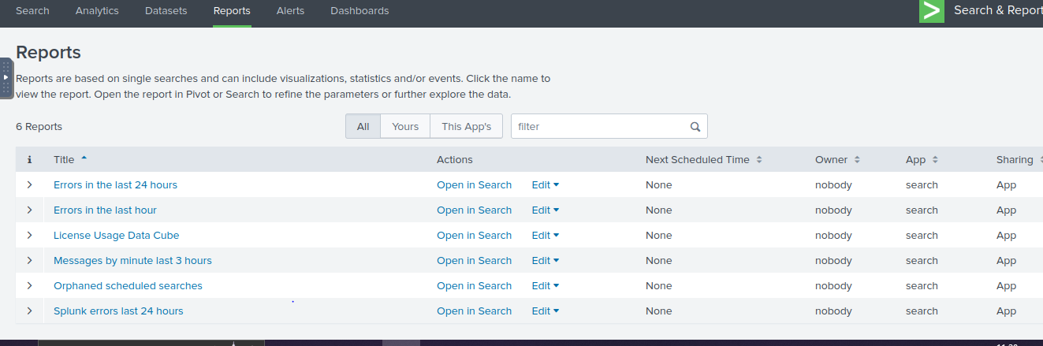

Usernames in the vpn server

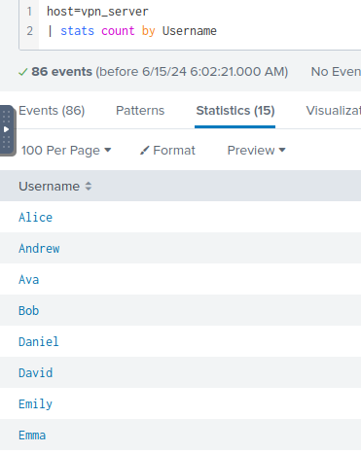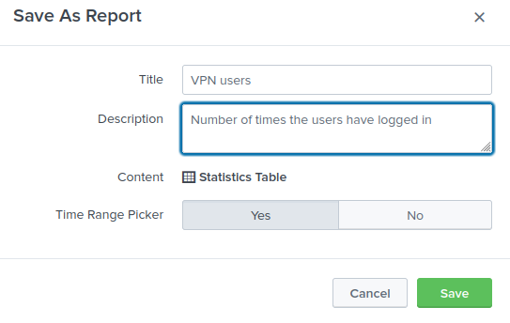

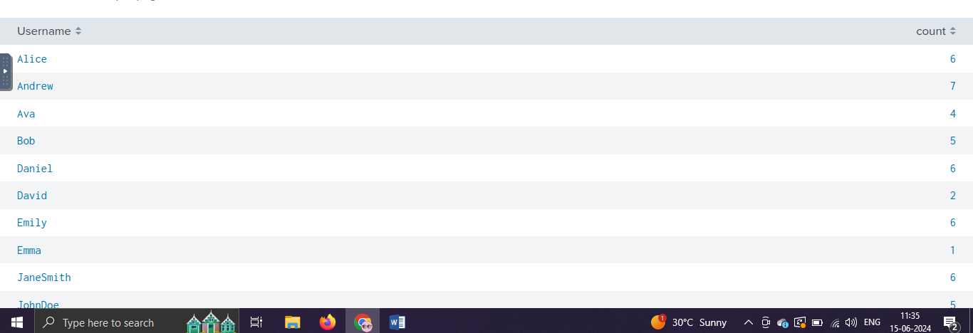

For the host network server. The ports are checked

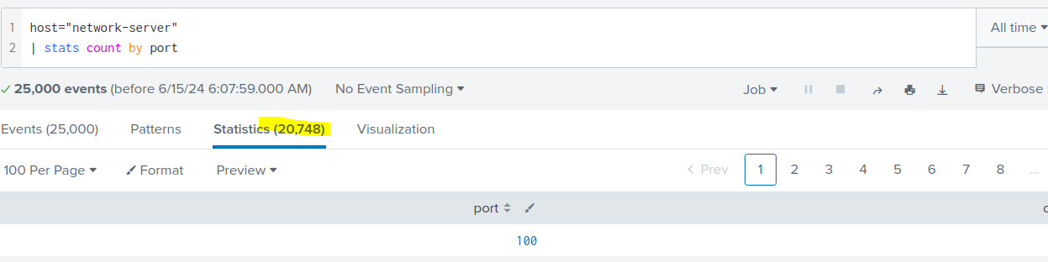

Ports with the highest count

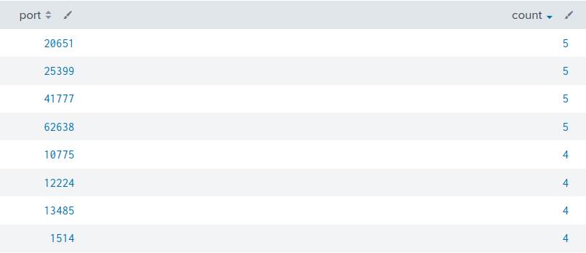

Dashboards

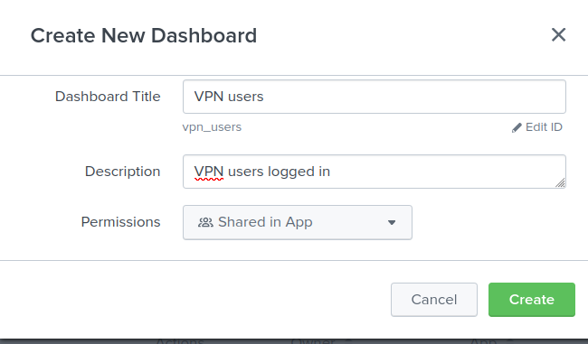

ADD panel from the vpn users report built

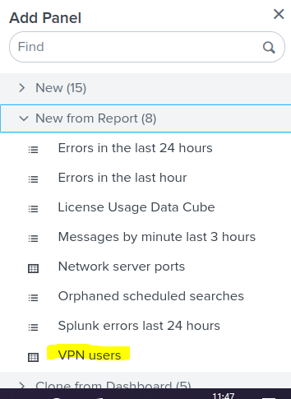

Vpn users

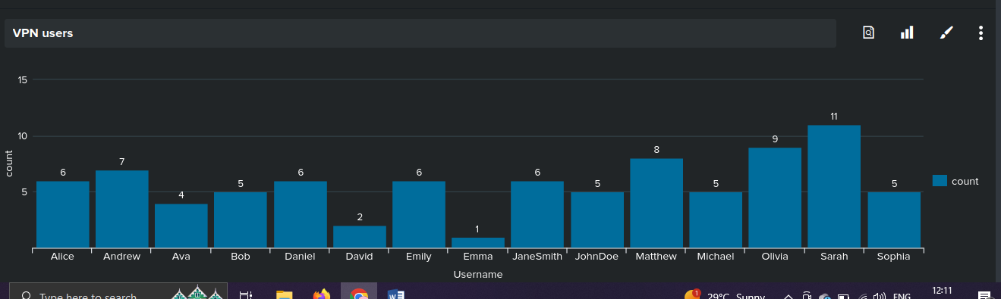

The count is visible above

New dashboard for webserver

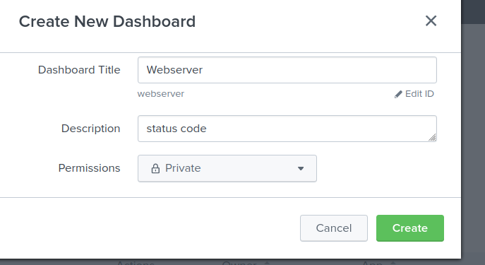

Add panel from the report created

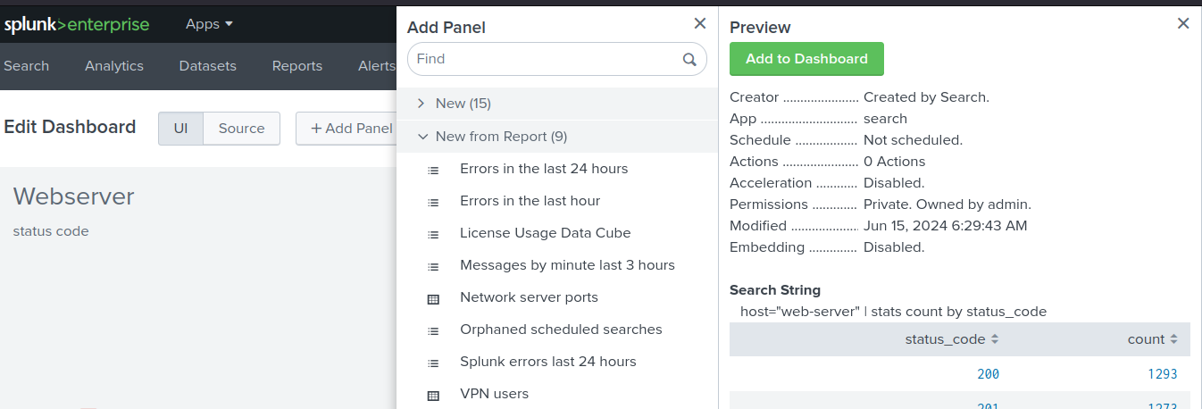

Visualization

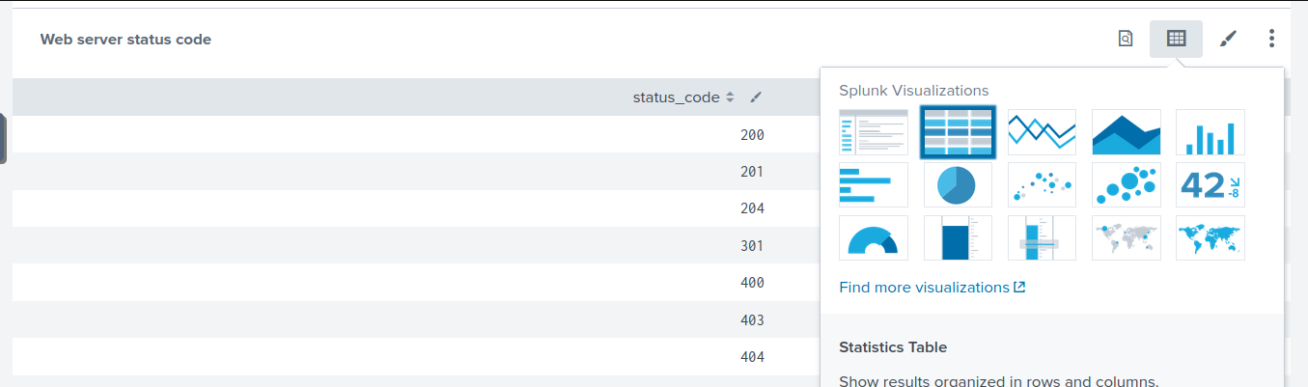

Column chart data visualization – min and max values presented

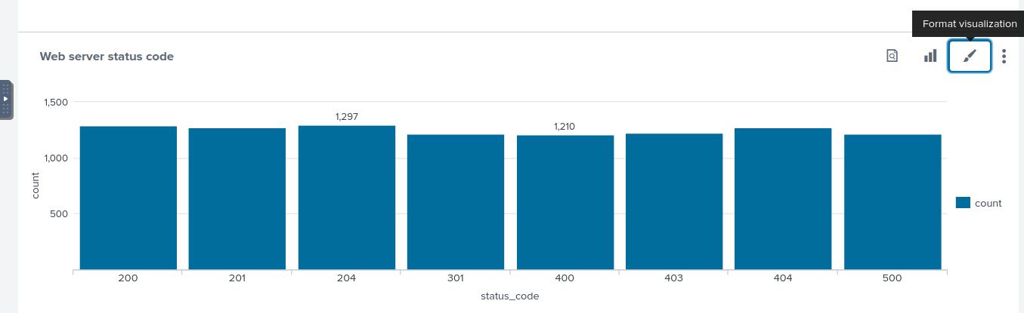

Alerting on high priority events

Start with the user

